William Borum

CS220

Prof Arias

04/07/2017

Project 2: Semester Project – Movie Theatre Ticketer Milestone

Abstract

The project that I settled on has to do with movie theatres and the interaction with the moviegoer and the information necessary to get them to buy a ticket. The java programs I created are meant to reenact that experience and spur users to go see movies for themselves.

Introduction

Of the three typical project groupings, I immediately gravitated towards a database project. I find it more enjoyable and practical to work with real-world data. Also, getting experience using a database, I feel, is most helpful in preparation for any type of applied math or computer science job. To make this project more interesting, I thought I would use a database that had to do with movies. In line with this idea, I proposed to make a movie theatre ticketing program. I will lay out the goals, aims, and aspects of a project that deals with movie theatres.

Detailed System Description

As of right now, the user starts with the Movie.java file and uses the main method to interact with the program. The method invokes another called askUser() that prompts the user to enter the number of the movie that the user wants to get more information about. The list of movies is taken from fandango.com, by scraping the html code for movies near a certain zip code. The user is then presented with key facts about the movie and its plot/synopsis. This is done by grabbing JSON data from omdbapi.com using the title as a search parameter. The information is parsed and put into the MovieData.java collection so that multiple movies can be displayed should the user need to search multiple movies. Below is the UML Diagram for the Movie.java and MoviData.java.

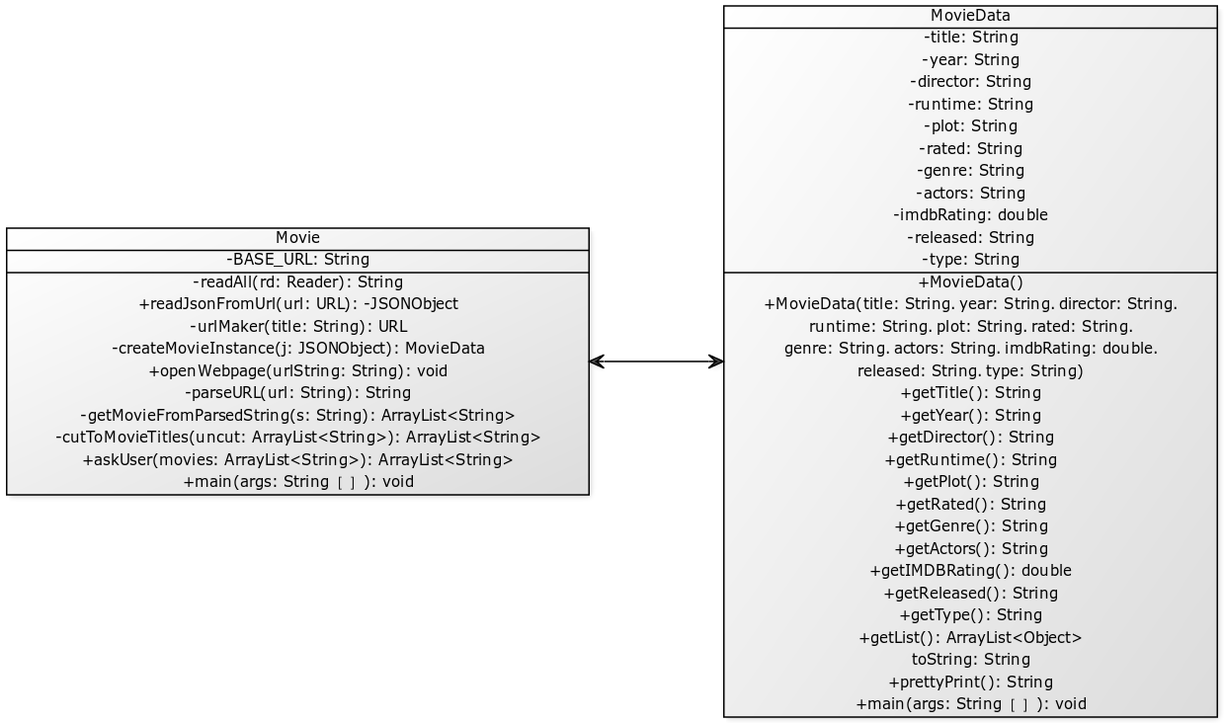

In the coming weeks, I have plenty to work on. I need to let the user pick the zip code that corresponds to where they live. I also need to use the openWebpage() method to give the user a way to actually buy a ticket, either on Fandango or on another website. Lastly, I need to handle errors more gracefully; right now, there are 3D versions of movies that will not show information using omdbapi, and some other small errors result from over-specific titles.

Requirements

My program helps users to decide what movie they want to see, and it does so by walking the user through a methodical process. This level of attention is what I hope will get through to people, as nowadays with everything online, people will not take time to decide what movie they want to see. This project will get those who use it to think on what makes a good movie theatre choice, and remind them what makes the movies great.

Literature Survey

Many online services offer similar functionality to my program. Some of the biggest ones are IMDB, Fandango, and Google, which all display this information in beautiful ways through html. Fandango is great in that you can actually buy tickets to the movies. Google is good as well because most people will not need to enter another website, as Google displays times for movies on its own search page. And lastly, IMDB is fantastic in that it has nearly all information on movies, actors, directors, reviews, and anything related to movies you can think of.

User Manual

Start by making sure Movie.java and MovieData.java are in the same directory. Compile Movie.java and run it to activate its main method. Look at the list of movies near Poughkeepsie, NY. Find one that looks interesting and type the corresponding number into the terminal. Press enter. A couple of sentences of details will be displayed about the movie you have chosen. Repeat for any movie that you like.